8.1.3 Editors - Image Editor - Header - Image menu
Image Editor - Image Menu 2
New 2
Name 2
Width 2
Height 2
Color 2
Alpha 2
Generated Type 2
32 Bit Float 3
Open Image 3
Open Cached Render 3
Replace Image 3
Reload Image 3
Edit Externally 3
Save Image 3
Save As Image 4
Save Copy 4
Save all Images 4
Invert 4
Resize 4
Pack Image / Pack as PNG 4

Image Editor - Image Menu

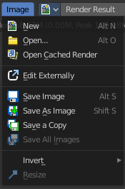
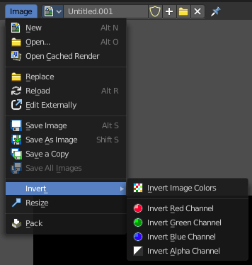
The Image menu contains the load and save functionality.
It is available in all sub modes. But not all content shows in all combinations.

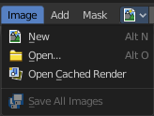

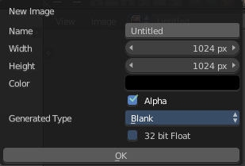
New
Creates a new image. You will get a dialog where you can define settings for the new image.

Name
The name of the new image

Width
The width of the new image.

Height
The height of the new image.

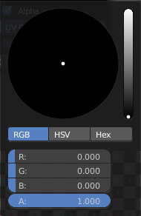
Color
Here you can adjust the color of the new image. A click will call a color picker.

Alpha
Check this checkbox if the new image should have an alpha channel.

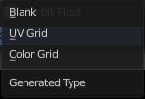
Generated Type
Here you can define what kind of texture you want to create.
Blank is one plain color.
UV Grid is a checker texture in black and white.
Color Grid is a colored checker texture.

32 Bit Float
Check this checkbox if the image should be in 32 Bit floating point bit depth per channel. Else it is in 8 bit per channel.

Open Image
Opens the file browser to load an image.

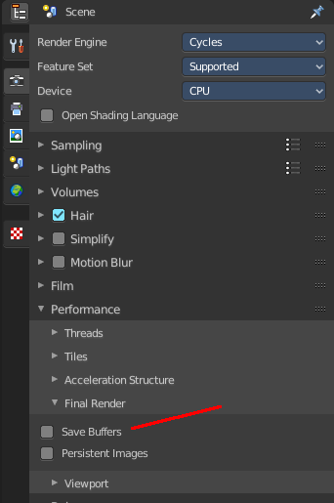
Open Cached Render
To get it to work you need to have Cycles as the renderer selected. This feature does not work with Eevee or Workbench renderer.
Read all the current scene's render layers from cache, as needed. For this featute to work save Buffers needs to be activated in the Performance tab in the render settings.
This feature can be be used to save RAM while rendering because the render layers do not have to be saved in RAM. It can also be used to recover some information from a fail render.

Replace Image
Replaces the currently active image by an image that you load.

Reload Image
Reloads the currently selected image.
Note that the images must already exist somewhere at your hard disk. When you create a new image in Bforartists, then this image isn't saved yet, and so you cannot reload it.

Edit Externally
Here you can open the image in a defined external image editor like The Gimp or Photoshop.
The image must be saved. And the image editor must be defined in the User Preferences.

Save Image
Saves the currently selected image without any further questions. Note that the images must already exist somewhere at your hard disk.

Save As Image
Saves the currently selected image.

Save Copy
Saves a copy of the currently selected image. This will save the file to a specified name, but will keep the old one open in the Image editor.

Save all Images
Saves all images.
Note that the images must already exist somewhere at your hard disk so that they can be saved. The item is greyed out as long as the image is not saved to disk.

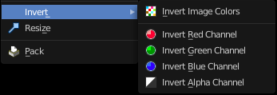
Invert
Invert is a sub menu where you can invert the colors of the whole image, or just specific colors.

Resize
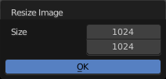
Allows you to change the dimensions of the image. The tool calls a resize panel.

Pack Image / Pack as PNG
Packs the currently active image into the blend file. When you save the blend file the next time, then this image will be embedded. The Pack menu item turns into a Unpack menu item with packed textures.
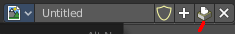
Packed images are marked with a pack icon. A click at this icon will unpack the texture, and try to save it to file. Usually to the last existing location before it was packed.
Warnning
You cannot modify packed images. Changes at the image will not be saved. You need to unpack the image when you want to modify it. And repack it after you have done the changes.

